Climate Change Adaptation Vulnerability Assessment Concept Tool – Getting Started

Prepared by CSIR Team

November 2012

# Introduction

A draft Climate Change Adaptation Vulnerability Assessment Tool has been developed to enable initial discussion of the current status of climate change adaptation and associated disaster risk management activities within Mozambique.

The tool can currently be accessed via an on-line system, [www.wqms.co.za](http://www.wqms.co.za). Data can be entered and updated on the system at any time. In the next phase, the tool and system will be re-packaged to suit client specific needs.

This document provides some first steps for getting started with the tool.

# Step 1: Register and Access the Tool

A login can be obtained by emailing Philip da Souza on [philipds@emanti.co.za](mailto:philipds@emanti.co.za).

Go to [www.wqms.co.za](http://www.wqms.co.za) and enter your login details.

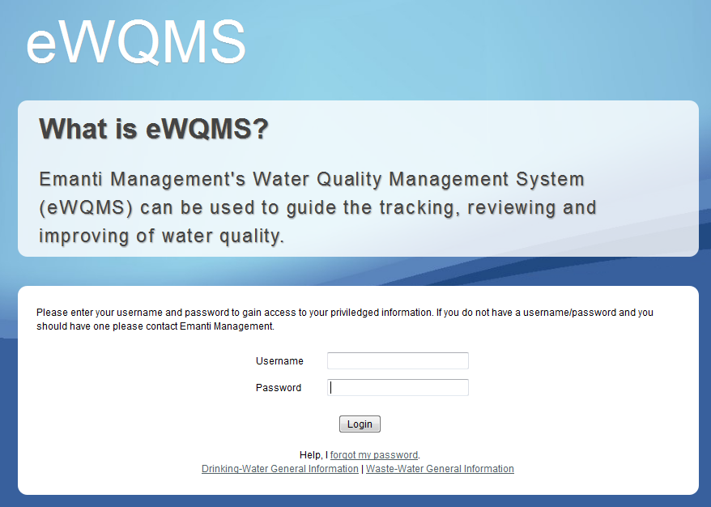

# Step 2: Risk Toolbox

Once you have accessed the system, go to Risk Toolbox and select the “Climate Change Adaptation Vulnerability Assessment”.

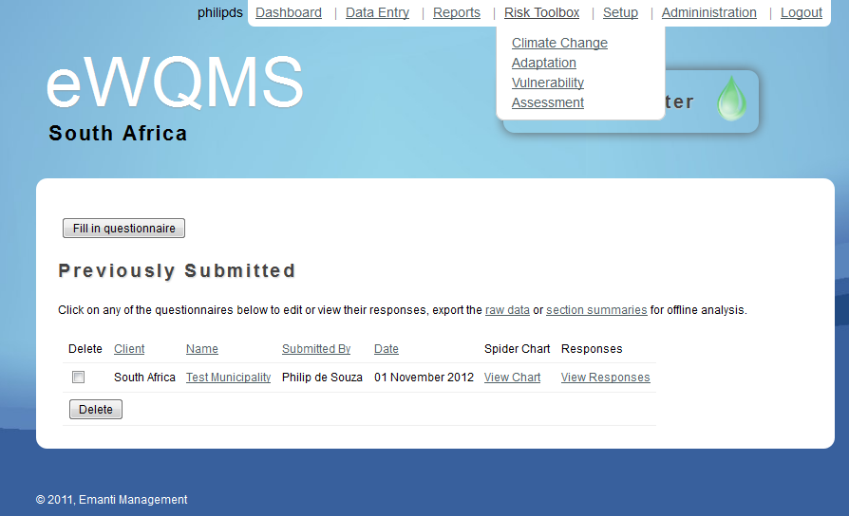

(***NOTE:*** Please ignore the other headings, water type, etc for the time being. These aspects will be addressed in the next phase).

# Step 3: Complete Assessment

Click on “fill in questionnaire”. Enter a name of the area/system/Municipality that you are assessing. Press save.

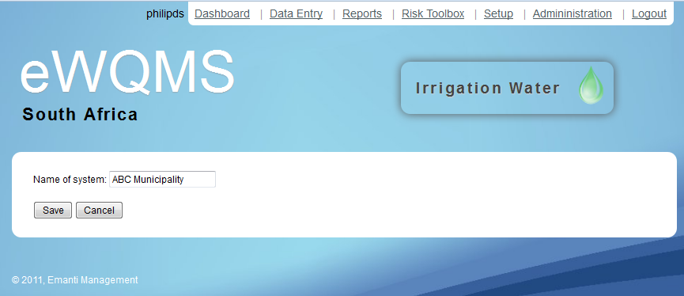

Answer the questions by selecting the most appropriate answer from the drop-down.

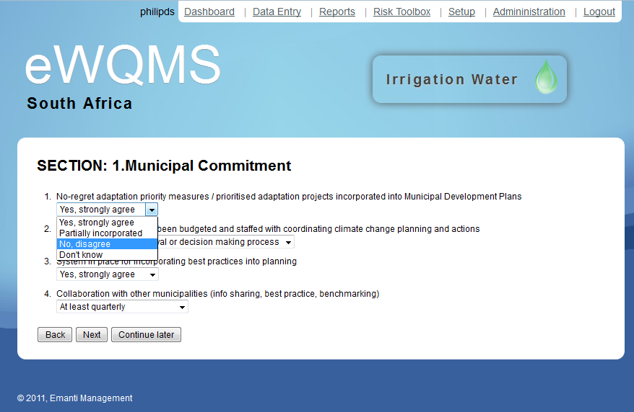

Click “next” to go to Section 2.

Complete all 9 sections of the Tool.

# Step 4: View performance

Once all sections are complete, click on “View Spider Chart”.

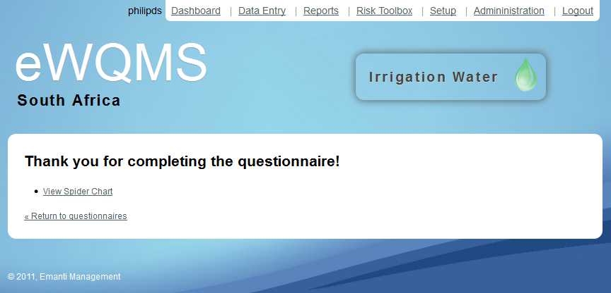

The vulnerability spider-diagram will be displayed.

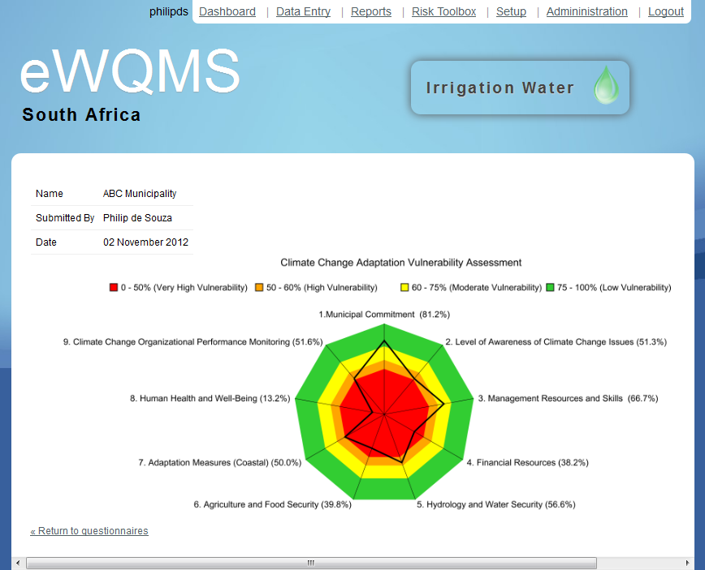

To return to all questionnaires (e.g. to view completed questionnaires or make amendments), click on “Return to questionnaires”.

To view all provided answers, click on “View Responses”.

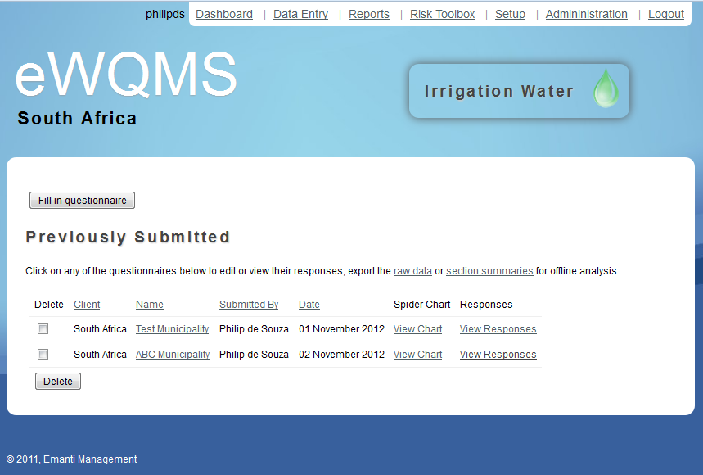

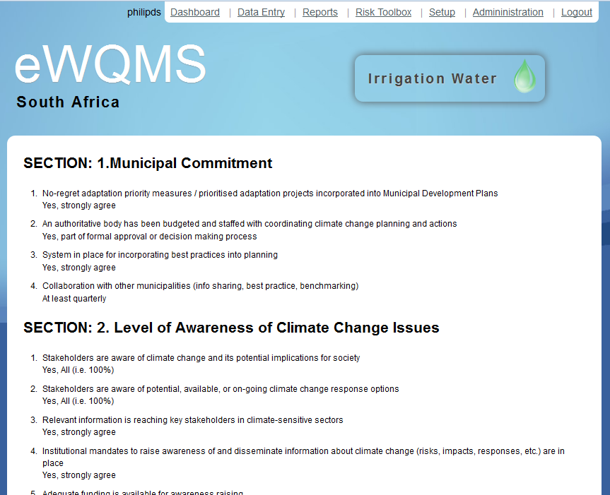

# Getting help

For further assistance on using the Tool, please contact [philipds@emanti.co.za](mailto:philipds@emanti.co.za).